Transpose graph:-

Transpose of a directed graph G is another directed graph on the same set of vertices with all of the edges reversed compared to the orientation of the corresponding edges in G. That is, if G contains an edge (u, v) then the converse/transpose/reverse of G contains an edge (v, u) and vice versa.

Given a graph (represented as adjacency list), we need to find another graph which is the transpose of the given graph.

**Example:-**

[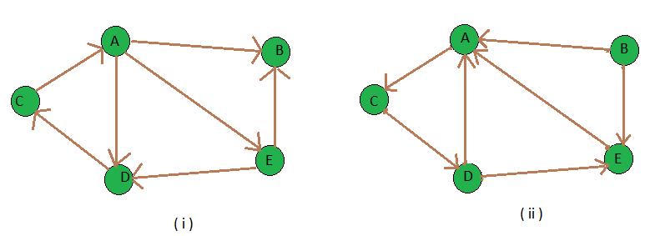](https://media.geeksforgeeks.org/wp-content/uploads/transpose_both.png)

In above graph both are transpose of each other.